**Protein Analysis User Guide**

1. Introduction

Protein Analysis is a program that runs analysis on protein simulations run in OpenMM and visualized with VMD. This analysis can be run from a Python Integrated Development Environment (IDE) or from the command line.

There are three folders in this project:

* Output – Where any Output created by this program should be placed
* Resources – Where the data from the simulations should be placed
* Source – Where the code for this program is placed

1. Installation

TBD

1. Running Analysis

Running an analysis has a few simple steps. First, you must have a completed simulation from OpenMM with a log file. This log file MUST be placed in the Resources folder. If you want to run RMSD analysis then a .dat file must be created in VMD.

Creating a .dat file in VMD

* A full tutorial on using VMD’s RMSD functionality is located [here](http://www.ks.uiuc.edu/Research/vmd/plugins/rmsdvt/)
* Once you have plotted the files you can go into the top right corner and click File->export as ASCII vector and then designate the file location and name for saving.

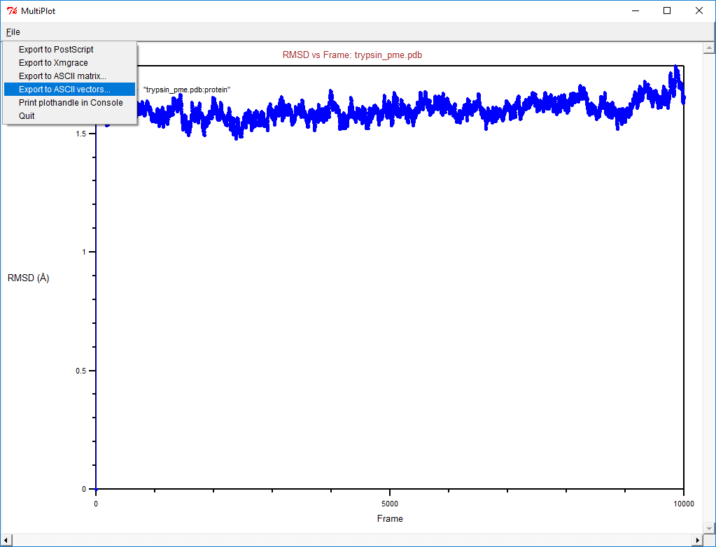

Once the .log file is loaded into the Resources you can run the program and follow the user prompts to run analysis for potential energy and RMSD.

1. Adding Analysis Functionality